Ordering  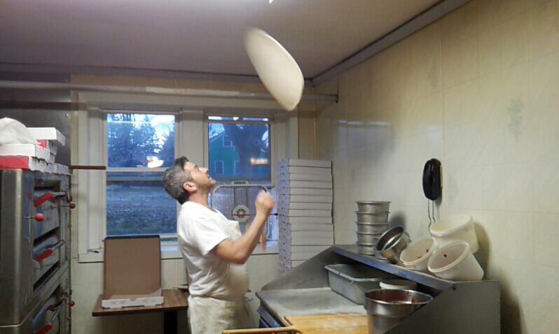  For carryout, call 908-782-0909  Cash or Check Only |  |  |  |  |  | Frank’s  Pizza  - www.FranksPizzaRingoes.com  - Celebrating Nearly 40 years!  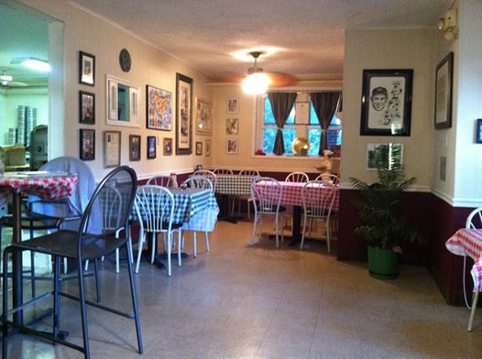
Open Tues-Saturday: 4-9  Open Sunday: 4-8  Closed Monday |  |  |  |  |  | 1032 Old York Road  Ringoes, NJ 08551  908-782-0909  Cash or Check Only  Like us on Facebook-Search for Frank’s Pizza of Ringoes!
Pizza  Small / Large  Plain Pie: 9.00 / 11.00  White Pie: 10.50 / 12.00  Hawaiian Pizza: 13.00 / 15.00  Eggplant Parm Pizza: ------- / 14.00  Sicilian Pizza: ------- / 14.00  “Nonna” Pie: ------- / 14.00  (Original Sicilian Pizza)  Meat Lover’s Pizza: 16.00 / 18.00  (pepperoni, sausage, meatball, bacon)  The Garden Pizza: 16.00 / 18.00  (mushroom, peppers, olives, broccoli, spinach)  Frank’s Special Pizza: 16.00 / 18.00  (sausage, mushroom, pepperoni, peppers, onions)  Pizza Toppings  Pizza Toppings $2.00 ea. – Sandwich fillings $1.00 ea.  Pepperoni Onion  Sausage Mushroom  Meatball Peppers  Steak Black Olives  Ham Spinach  Bacon Broccoli  Anchovies Tomato  Extra Cheese Pineapple  Garlic |  |  |  |  | Sandwiches  Small / Large  Meatball or Sausage Parm 7.00 / 11.00  Cheese Steak 7.00 / 11.00  Pizza Steak 7.00 / 11.00  Chicken Cheese Steak 7.00 / 11.00  Buffalo Chicken Cheese Steak 7.00 / 11.00  California Cheese Steak 7.00 / 11.00  (with mayo, lettuce, tomato & onion)  Chicken Cacciatore  Cheese Steak 7.00 / 11.00  (chicken with green peppers, onions & sauce)  Boardwalk Sausage 7.00 / 10.00  (grilled sausage with peppers, onions & olive oil)  Cheese Calzone OR Stromboli 8.00  Steak Stromboli 11.00  Build Your Own 8.00  ~fillings $1.00 each~  